CPE301 – SPRING 2019

Design Assignment 2A

Student Name: Geovanni Portillo

Student #: 8000603824

Student Email: [portig1@unlv.nevada.edu](mailto:portig1@unlv.nevada.edu)

Primary Github address: <https://github.com/portig1/submissions_E>

Directory: submissions_E/DA/LAB2A/

Submit the following for all Labs:

1. In the document, for each task submit the modified or included code (only) with highlights and justifications of the modifications. Also, include the comments.
2. Use the previously create a Github repository with a random name (no CPE/301, Lastname, Firstname). Place all labs under the root folder ESD301/DA, sub-folder named LABXX, with one document and one video link file for each lab, place modified asm/c files named as LabXX-TYY.asm/c.
3. If multiple asm/c files or other libraries are used, create a folder LabXX-TYY and place these files inside the folder.
4. The folder should have a) Word document (see template), b) source code file(s) and other include files, c) text file with youtube video links (see template).

1. **COMPONENTS LIST AND CONNECTION BLOCK DIAGRAM w/ PINS**

Atmel Studio 7

ATmega328PB Xplained mini

Multi-function Shield

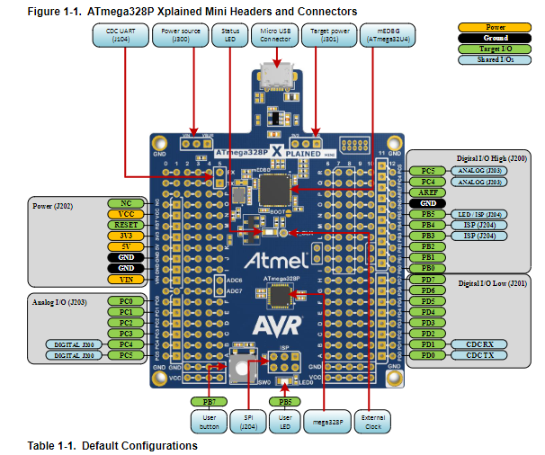

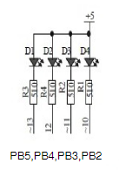

Multifunction Shield LED schematic

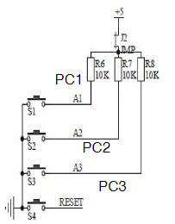

Multifunction Shield Switch Schematic

1. **INITIAL/MODIFIED/DEVELOPED CODE OF TASK 1/Assembly**

.org 0

;Set PORTB.2 For Output

SBI DDRB,2

LDI R16, 0

OUT PORTB, R16

; Toggle PORTB.2 on and off. On for 435ms and off for 290ms to achieve a period of 725ms with a duty cycle of 60%

; The LED connected to PORTB is active low so by setting PORTB.2 to 0, it is actually being turned on

L1: LDI R16, 0

OUT PORTB, R16

RCALL delay435ms

LDI R16, 4

OUT PORTB, R16

RCALL delay290ms

RJMP L1

delay435ms:

;Delay function is meant to have a delay of approximately 435ms for a clock at 16MHz, actual time is about 437ms

;Delay function from delayL0 and below takes 120,603 clock cycles

;So using the clock's ratio of 16 x 10^3 calculations per second and knowing that the period we need is 0.435s

;I found the clock cycles needed to be 6,960,000. 57.7 Iterations of the delay loop is needed so I rounded up to 58

LDI R19, 58

delayL0_A: LDI R20, 200

delayL1_A: LDI R21, 200

delayL2_A: DEC R21

BRNE delayL2_A

DEC R20

BRNE delayL1_A

DEC R19

BRNE delayL0_A

RET

delay290ms:

;Delay function is meant to have a delay of approximately 290ms for a clock at 16MHz but is closer to about 294ms

;Process is identical to that of the function above. Clock cycles needed are 4,640,000 and require 38.5 iterations rounded up

LDI R19, 39

delayL0_B: LDI R20, 200

delayL1_B: LDI R21, 200

delayL2_B: DEC R21

BRNE delayL2_B

DEC R20

BRNE delayL1_B

DEC R19

BRNE delayL0_B

RET

1. **DEVELOPED MODIFIED CODE OF TASK 2/Assembly from TASK 1/Assembly**

.org 0

;Set PORTB.2 For Output

SBI DDRB,2

LDI R16, 4

OUT PORTB, R16

;Set PORTC.2 For Input

CBI DDRC, 2

LDI R16, 4

OUT PORTC, R16

;If the switch connected to PINC.2 is pushed (Set to Low), PORTB.2 will be set to 0 and turn on the LED for 1.25s

L1:

SBIC PINC, 2 ;If PINC isn't cleared (Switch is pushed), RJMP LEDoff is exectued and the LED will be turned off, if not already

RJMP LEDoff

LDI R16, 0

OUT PORTB, R16

RCALL delay1250ms

RJMP L1

LEDoff: LDI R16, 4

OUT PORTB, R16

RJMP L1

delay1250ms:

;Delay function is meant to have a delay of approximately 435ms for a clock at 16MHz, actual time is about 437ms

;Identical to delay function used in Task 1, clock cycles needed are 20,000,000 and require 165.8 iterations rounded up

LDI R19, 166

delayL0_A: LDI R20, 200

delayL1_A: LDI R21, 200

delayL2_A: DEC R21

BRNE delayL2_A

DEC R20

BRNE delayL1_A

DEC R19

BRNE delayL0_A

RET

1. **INITIAL/MODIFIED/DEVELOPED CODE OF TASK 1/C Code**

#include <avr/io.h>

/* - LED connected to PORTB.2 */

int main (void)

{

/* set PORTB.2 for output*/

DDRB |= (1 << 2);

PORTB |= (1 << 2);

long i;

/* Toggle PORTB.2 on and off. On for 435ms and off for 290ms to achieve a period of 725ms with a duty cycle of 60%

The LED connected to PORTB is active low so by setting PORTB.2 to 0, it is actually being turned on */

/* For a counter set to 16,000,000, it takes 96000004 clock cycles to complete a countdown and it takes 6s to complete

using this ratio, I calculated to get a time of 0.435s the counter needs to be set around 1,160,000 and for 0.29s a counter of 773,333 */

while (1) {

i = 1160000;

PORTB = _BV(PINB2);

while (i > 0) {

i--;

};

i = 773333;

PORTB = ~(_BV(PINB2));

while (i > 0) {

i--;

};

}

return 0;

}

1. **DEVELOPED MODIFIED CODE OF TASK 2/C Code from TASK 1/C Code**

#include <avr/io.h>

/* - LED connected to PORTB.2 */

/* - Switch connected to PORTC.2 */

int main (void)

{

long i; //initialize i for counter

/* set PORTB.2 for output*/

DDRB |= (1 << 2);

PORTB |= (1 << 2);

/* set PORTC.2 for input*/

DDRC &= (0 << 2);

PORTC |= (1 << 2); //enable pull-up

/* A switch is connected to PORTC.2 and when pressed PINC.2 is set low. Condition for the if statment is then true

and the LED will turn on for 1.25s. Using the ratio found in Task1_ I calculated the counter needs to be set to

333,333 to have a delay of approximately 1.25s*/

while (1) {

if(!(PINC & (1 << PINC2)))

{

PORTB &= ~(1 << 2);

i = 3333333;

while (i > 0) {

i--;

};

}

else

PORTB |= (1 << 2);

}

return 0;

}

1. **SCHEMATICS**

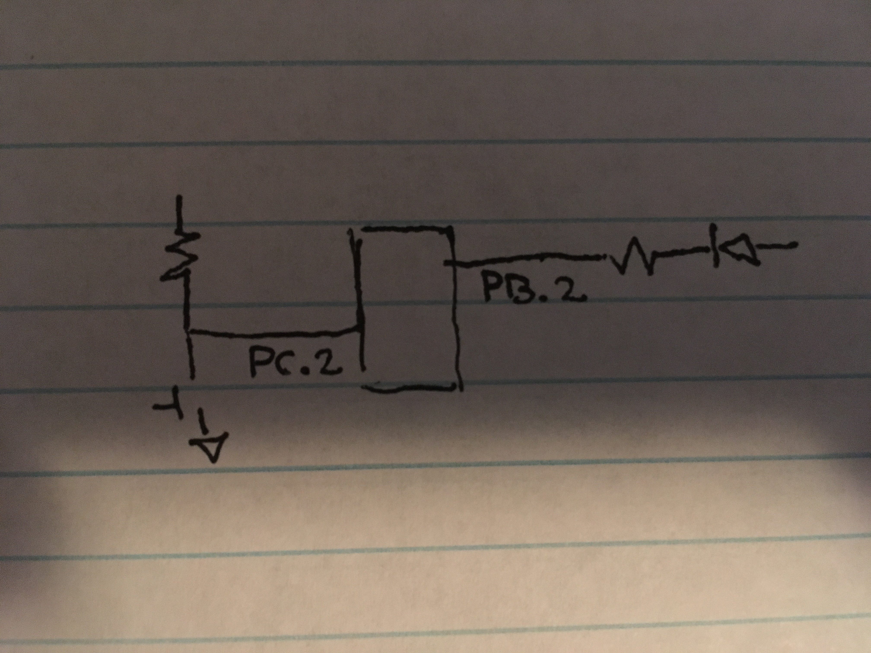

Schematic showing connections for PORTB.2 and PORTC.2

1. **SCREENSHOTS OF EACH TASK OUTPUT (ATMEL STUDIO OUTPUT)**

Not asked for in Design Assignment 2A instructions

1. **SCREENSHOT OF EACH DEMO (BOARD SETUP)**

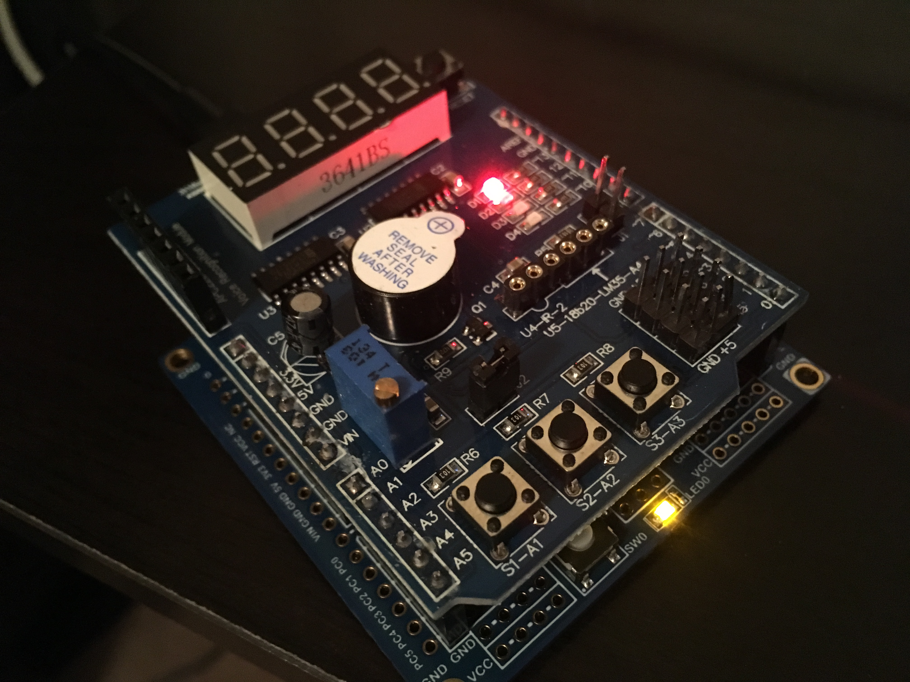

Board setup for Tasks 1 and 2 (Assembly and C)

1. **VIDEO LINKS OF EACH DEMO**

<https://youtu.be/Jv3t5SKwIiE>

1. **GITHUB LINK OF THIS DA**

<https://github.com/portig1/submissions_E/tree/master/DA/LAB1B>

**Student Academic Misconduct Policy**

<http://studentconduct.unlv.edu/misconduct/policy.html>

“This assignment submission is my own, original work”.

Geovanni Portillo